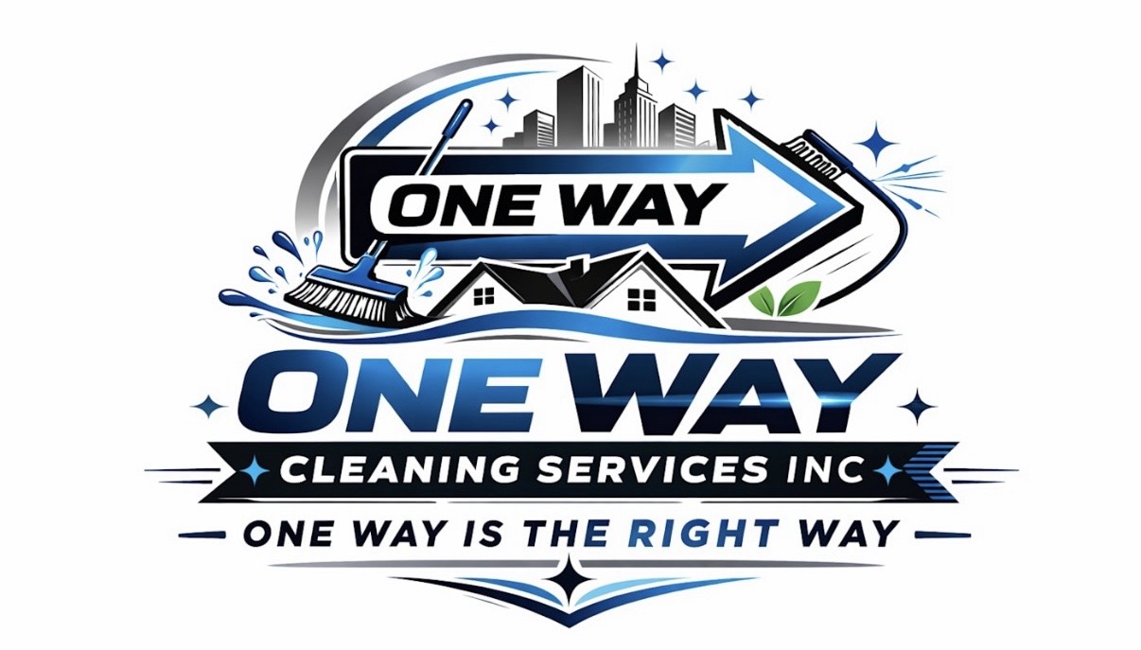

One Way Cleaning Services Inc.

Paystub
Employee: {{employee}}
Pay Date: {{pay_date}}
Pay Period: {{period_start}} – {{period_end}}
Hours Worked: {{hours}}
Hourly Rate: ${{rate}}
Filing Status: {{filling_status}}
Dependents: {{dependent}}

Earnings
Description | Hours | Rate | Amount
Regular Pay | {{regular_hours}} | ${{rate}} | ${{regular_pay}}
Overtime Pay (1.5x) | {{overtime_hours}} | ${{rate}} | ${{overtime_pay}}

Gross Pay: ${{subtotal}}

Deductions (Estimated)
Description | Amount
Social Security (6.2%) | ${{ss}}
Medicare (1.45%) | ${{medicare}}

Total Deductions: ${{deductions}}

Net Pay
Net Pay: ${{net_pay}}

Notes: {{notes}}

Spotless or We’ll Make It Right—Guaranteed

Business Info:
One Way Cleaning Services Inc.
Miami-Dade & Southern Broward, FL
Phone: 786-587-9357
onewaycleaning.com

This paystub is for informational purposes only. Please review and confirm all details. Contact Mixene with any questions.

